Takeaway:

Analysis of all trials (separated by fix x congruency) shows no significant main effects or interactions

Also no significant interactions when looking just at White trials and just at Black trials

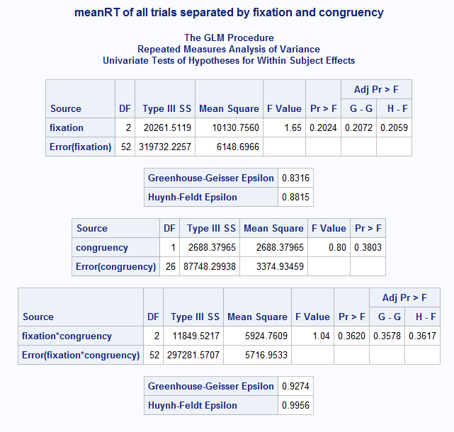

**proc** **glm** data=alldat;

model eyes_con eyes_inc fore_con fore_inc nose_con nose_inc= /nouni;

repeated fixation **3**, congruency **2**;

title 'meanRT of all trials separated by fixation and congruency';

**run**;

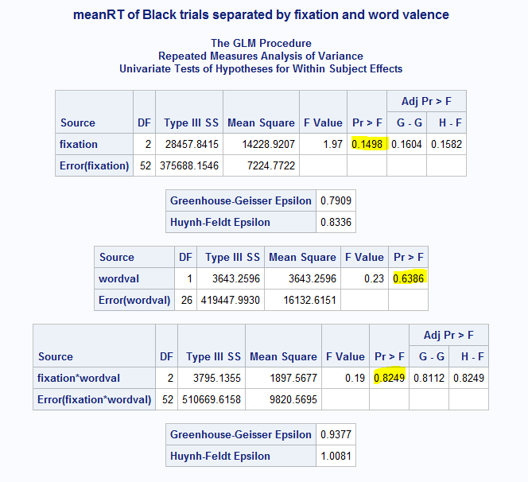

**proc** **glm** data=blackdat;

model eyes_pos eyes_neg fore_pos fore_neg nose_pos nose_neg= /nouni;

repeated fixation **3**, wordval **2**;

title 'meanRT of Black trials separated by fixation and word valence';

**run**;

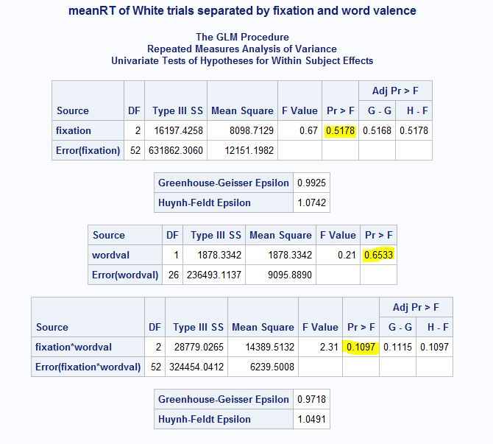

**proc** **glm** data=whitedat;

model eyes_pos eyes_neg fore_pos fore_neg nose_pos nose_neg= /nouni;

repeated fixation **3**, wordval **2**;

title 'meanRT of White trials separated by fixation and word valence';

**run**;

Repeated measures ANOVA- use if there are any within subject variables

Factorial ANOVA- if everything is between subjects

One way ANOVA- if there’s only one variable with multiple levels